**BSE20-43**

**SMART HOME SYSTEM**

**SOFTWARE DESIGN DOCUMENT**

|  |  |  |  |
| --- | --- | --- | --- |
| # | Names | Registration Number | Signature |
| 1 | Thakkar Brinda Sanjaykumar | 16/X/2271/PS |  |
| 2 | Waiswa Brian Victor | 16/U/1254 |  |
| 3 | Kyaka Herman Ceaser | 15/U/6851/PS |  |
| 4 | Ddombo Nasser | 15/U/4898/EVE |  |

**DEPARTMENT OF NETWORKS**

**MAKERERE UNIVERSITY**

**12TH FEBRUARY 2020**

Table of Contents

1. INTRODUCTION 6

1.1 PURPOSE 6

1.2 SCOPE 6

1.3 OVERVIEW 6

1.4 REFERENCE MATERIAL 7

1.5 DEFINITIONS AND ACRONYMS 7

2. SYSTEM OVERVIEW 8

3. SYSTEM ARCHITECTURE 9

3.1 ARCHITECTURAL DESIGN 9

3.2 DECOMPOSITION DESCRIPTION 10

3.2.1 ARDUINO UNO MICRO-CONTROLLER 10

3.2.2 LIGHT SENSOR 11

3.2.3 TEMPERATURE SENSOR 11

3.2.4 MOTION SENSOR 12

3.2.5 SMOKE SENSOR 12

3.2.6 MOBILE APPLICATION 13

3.2.7 DATABASE 13

3.2.8 TOP LEVEL DATA FLOW DIAGRAM FOR THE SMART HOME SYSTEM 13

3.3 DESIGN RATIONALE 14

4. DATA DESIGN 15

4.1 DATA DESCRIPTION 15

4.2 DATA DICTIONARY 16

5. COMPONENT DESIGN 17

5.1 LIGHT CONTROL 17

5.2 MOTION DETECTION 17

5.3 TEMPERATURE CONTROL 17

5.4 ALARM AND SMOKE DETECTION 18

5.5 MOBILE APPLICATION 18

5.6 DATABASE 18

6. HUMAN INTERFACE DESIGN 19

6.1 OVERVIEW OF USER INTERFACE 19

6.2 SCREEN IMAGES 20

6.2.1 LOGIN SCREEN 20

6.2.2 INTERFACE FOR LIGHTS CONROL 21

6.2.3 INTERFACE FOR DOORS 22

6.2.4 INTERFACE FOR FAN 23

6.3 SCREEN OBJECTS AND ACTIONS 24

7. REQUIREMENTS MATRIX 25

**List of figures**

Figure 3. 1 System Architecture 9

Figure 3. 2 Arduino UNO Micro-controller 10

Figure 3. 3 Light sensor 11

Figure 3. 4 Temperature sensor 11

Figure 3. 5 Motion sensor 12

Figure 3. 6 Smoke sensor 12

Figure 3. 7 Mobile application 13

Figure 3. 8 Database 13

Figure 3. 9 Data Flow Diagram 14

Figure 6. 1 Use case diagram 19

Figure 6. 2 Login interface 20

Figure 6. 3 Interface for lights 21

Figure 6. 4 Interface for controlling doors 22

Figure 6. 5 Interface for controlling fan 23

**List of tables**

Table 4. 1 The data types and description for the sensors 15

Table 4. 2 The data description for the data which will be stored from the mobile application 16

Table 7. 1 Cross-reference of system components and functional requirements 25

# INTRODUCTION

## 1.1 PURPOSE

This software design document provides description for the design and architecture of the Smart Home System, for the software developers and other technical users of the system to understand what is to be built and how it is supposed to be built. It also provides detailed information of the system to be built. This document is intended for developers, testers and project managers to understand the system to be built.

## 1.2 SCOPE

This system will focus primarily on automating the process of switching on and off of lights, opening and closing of doors, and switching on and off of different home appliances like TV, fans, coolers, alarms, smoke detection and temperature control for houses that are going to use this system.

This system will help users to have their homes automated and live an easy and comfortable life. The main objective of this system is to improve the quality of life and the convenience at home for the users of this system. Life will be easier for the users of this system as most of the home appliances will be automated and it will also save their time.

## 1.3 OVERVIEW

The SDD is divided into different sections with various sub sections under those sections.

Introduction – it provides the purpose, the goal, objectives, benefits, intended audience and references.

System overview – it includes the description of functionality and design of the system.

System architecture – it explains the relationships between each module and also provides a decomposition of subsystems.

Data design – explains how the information is transformed into data structures.

Component design – it describes the algorithm and its procedure, functions of each object

Interface design – it shows the functionality of the system from the user’s perspective.

## 1.4 REFERENCE MATERIAL

## 1.5 DEFINITIONS AND ACRONYMS

SDD – Software Design Document

# SYSTEM OVERVIEW

In Uganda today, most people control their appliances manually and they need a way to automate the activities in their homes to make their life easy and comfortable. The proposed system will address the problem of the managing and controlling of the home activities manually.

Smart Home system is a generic solution that will automate the process of the usage and control of different home appliances and will add an extra layer of security to the home. The system will work automatically through use of different sensors like light sensors, motion detectors, temperature sensors which data will trigger certain events turning on and off of lights, turning on and off of fans, opening and closing of doors. The client will also have the ability to override the system through use of a mobile application after being authenticated and authorized by the system.

# SYSTEM ARCHITECTURE

## ARCHITECTURAL DESIGN

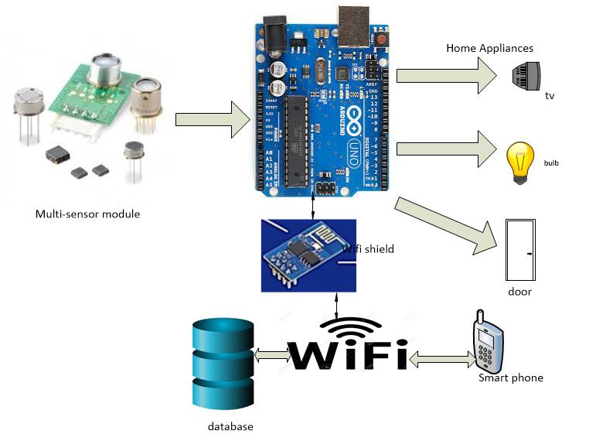

Figure 3. System Architecture

This section shows the architecture design for the Smart home system. The system will consist of four major components which will form a complete smart home system.

Arduino UNO micro-controller will control all the functions and interactions between the sensors, home appliances and the mobile application. It will also send signals to different home appliances after receiving the status reports from the sensors.

The sensors are very important component of the system as it will help the Arduino UNO to control the switching on/off of the different home devices using the light sensor, temperature sensor, motion sensor, smoke sensor. It will also trigger the alarm whenever it receives signal from the smoke sensor.

Home appliances are another main component of the system as the Arduino UNO will interact with them to perform different functions.

Mobile application is a small but important component of the system as it will be used to login to the system to perform different functions such as switching on/off lights, fans, etc. through wireless connection.

Database will also be a part of the system as it will store the user login information and records of the sensors.

## 3.2 DECOMPOSITION DESCRIPTION

### 3.2.1 ARDUINO UNO MICRO-CONTROLLER

Arduino UNO micro-controller will be used to process data received from the sensors and it will also interact with the home appliances and the mobile application.

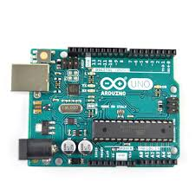

Figure 3. Arduino UNO Micro-controller

### 3.2.2 LIGHT SENSOR

The light sensor will detect light and will send signals to Arduino UNO so that it can handle the switching on/off of the lights.

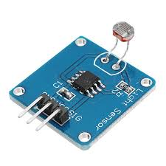

Figure 3. Light sensor

### 3.2.3 TEMPERATURE SENSOR

It will detect the level of temperature in the surrounding environment and send signals to Arduino UNO to switch on/off the fans.

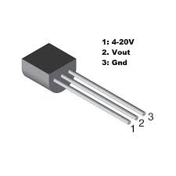

Figure 3. Temperature sensor

### 3.2.4 MOTION SENSOR

It will detect the movement in the house and will send signal to the Arduino UNO and it will handle the opening and closing of the doors accordingly.

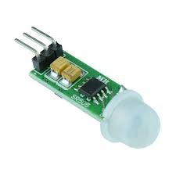

Figure 3. Motion sensor

### 3.2.5 SMOKE SENSOR

It will detect the smoke in the house and also the fire and it will send signals to the Arduino UNO which will trigger the alarm to inform the user about the fire in the house.

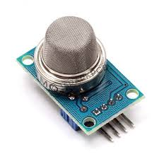

Figure 3. Smoke sensor

### 3.2.6 MOBILE APPLICATION

The mobile application will be used to communicate with the system and home appliances by the user to choose which device he/she wants to interact with at any time they want.



Figure 3. Mobile application

### 3.2.7 DATABASE

The database will store the user information entered by the users in the mobile application to keep record of the personal information and to restrict any unauthenticated user to interact with the system. It will also store the data received from the different sensors.

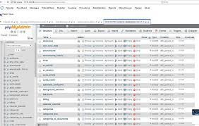

Figure 3. Database

### 3.2.8 TOP LEVEL DATA FLOW DIAGRAM FOR THE SMART HOME SYSTEM

The proposed system will interact with entities such as sensors, home appliances and the mobile application as shown in the Figure 3.2. In this the different sensors will capture parameters from the surrounding environment and will be sent to the Smart home system which will use the Arduino UNO to interact with different home appliances. The mobile application will also be used to interact with the home appliances through the Arduino UNO using the wireless connection.

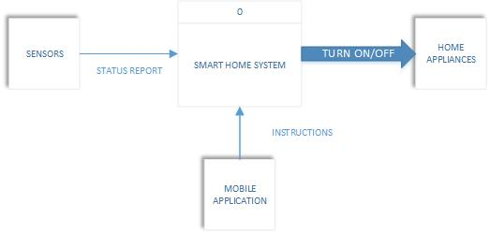

Figure 3. Data Flow Diagram

## 3.3 DESIGN RATIONALE

We are using the Arduino UNO micro-controller as it is very effective and efficient to use while we interacting with sensors and different devices and it is easy to do programming with it.

We used a mobile application in order to interact with home appliances which will help the user to easily choose which device they want to control at any time they want. The mobile application will be connected to a database in order to capture the user login details.

# 4. DATA DESIGN

## 4.1 DATA DESCRIPTION

The proposed Smart home system will have four types of sensors;

Light sensors which will detect the set level and will turn on/off the lights accordingly and will store the voltage in the database after converting it into integers.

Temperature sensor will detect the temperature and will be used to control the level of hotness, coolness and humidity in the house. It will also send signals to other devices in order to turn on/off the fans. It will store the Celsius degrees after converting it into integer data type in the database.

Motion sensors will detect the movement in the house and will send signal and trigger the alarm. It will store the converted integer data type into the database.

Smoke sensors will detect the smoke levels or fire in the house and it will send signal to the alarm. It will store converted integer data type in the database accordingly.

|  |  |  |  |  |
| --- | --- | --- | --- | --- |
| Parameter | | Data type | Length | Description |
| Light sensor | | Integer | 15 | Will capture and store the converted voltage in the database |
| Temperature sensor | Degrees | Integer | 15 | Will capture the temperature and store the converted degrees in the database |
| Motion sensor | | Integer | 15 | Will capture the voltage and store it in the database |
| Smoke sensor | | Integer | 15 | Will store the converted voltage in the database |

Table 4. The data types and description for the sensors

## 4.2 DATA DICTIONARY

The proposed Smart home system also has mobile application which will be used to interact with the system in order to control all the devices.

When the user opens the mobile application he/she needs to login to the system with a username and password. All the usernames and passwords will be converted to varchar data type and will stored in the database.

|  |  |  |  |
| --- | --- | --- | --- |
| Parameter | Data type | Length | Description |
| Username | Varchar | 30 | It will store the username of the user in the database. It has a length of 30 characters. |
| Password | Varchar | 30 | It will store the password in the database. It has a length of 30 characters. |

Table 4. The data description for the data which will be stored from the mobile application

# 5. COMPONENT DESIGN

## 5.1 LIGHT CONTROL

This pseudocode controls the functions of the lights.

If the light sensor detects sunlight,

Then turn off lights;

Else turn on lights;

If user turns on lights,

Then turn on lights;

Else user turns off lights,

Turn off lights;

## 5.2 MOTION DETECTION

This pseudocode controls the functions for movement in the house.

If the sensor is on;

Then detect movement;

If movement detected;

Then trigger alarm;

Else no action;

## 5.3 TEMPERATURE CONTROL

This pseudocode controls the temperature in the house.

If the temperature is high,

Then turn on fan;

Else turn off the fan;

## 5.4 ALARM AND SMOKE DETECTION

This pseudocode controls the functions of the alarm and the smoke detector.

If smoke sensor detects smoke in the house,

Then trigger the alarm;

Else no action;

If user turns off the alarm,

Then turn it off;

Else no action;

## 5.5 MOBILE APPLICATION

This pseudocode controls the actions for the home appliances.

While user selects device,

If user selects the on button;

Then turn on the device;

Else if user selects off button;

Then turn off the device;

Else no action;

End while;

## 5.6 DATABASE

This pseudocode controls the data.

If user logs in;

Then store user details and verify;

Else no action;

# 6. HUMAN INTERFACE DESIGN

## 6.1 OVERVIEW OF USER INTERFACE

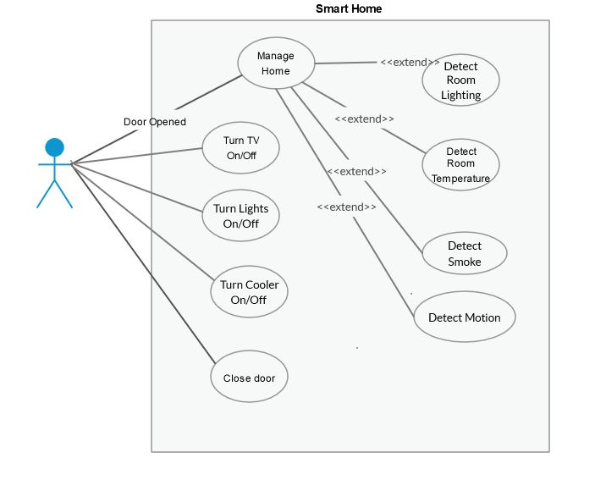

Figure 6. Use case diagram

The user shall interact with the system using the mobile application. The user selects to open or close the door from the mobile application.

The user will be able to manage all the home appliances using the mobile application. The user can select which home appliance he/she wants to turn on/off at any time they want. The user can select the on/off button in the mobile application to manage the home appliances. The user can select to turn on/off the lights from the mobile application when he/she doesn’t need it overriding the system.

The user shall also be able to turn on/off the cooler/fan at their convenience by selecting the button in the mobile application.

The user shall be able to turn off the alarm when he/she is travelling or not at home or any other reason.

## 6.2 SCREEN IMAGES

### 6.2.1 LOGIN SCREEN

This will be the user interface screen of the mobile application for the users to log in to the system using the username and password.

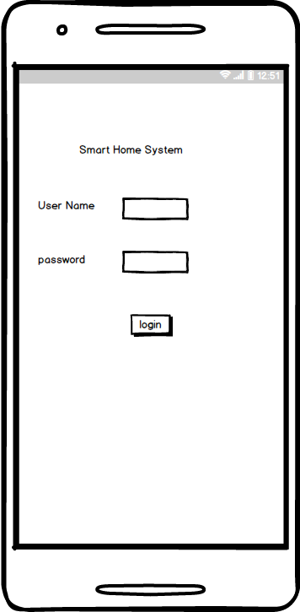

Figure 6. Login interface

### 6.2.2 INTERFACE FOR LIGHTS CONROL

This will be the user interface in the mobile application to allow users to select which lights they want to turn on/off.

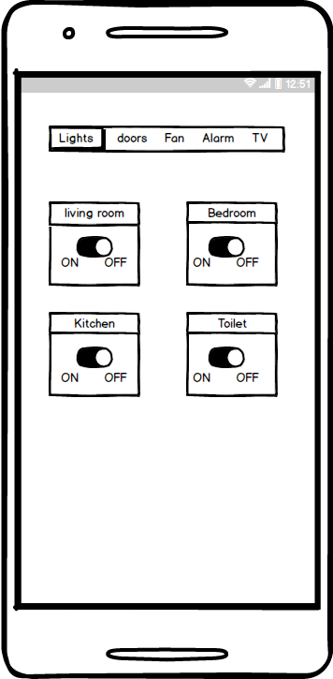

Figure 6. Interface for lights

### 6.2.3 INTERFACE FOR DOORS

This will be the user interface to allow users to select which door they want to open or close using the mobile application.

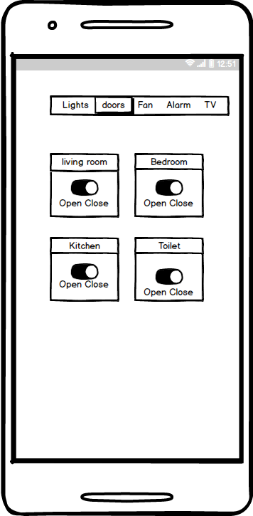

Figure 6. Interface for controlling doors

### 6.2.4 INTERFACE FOR FAN

This user interface will allow users to turn on/off the fan and also control the speed of the fan.

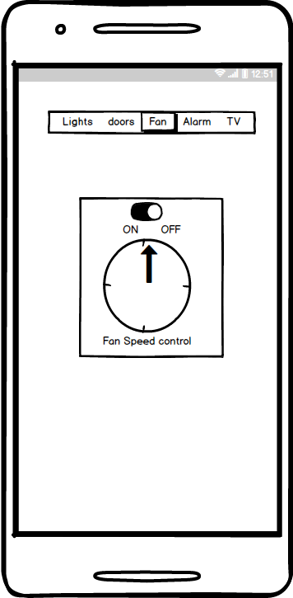

Figure 6. Interface for controlling fan

## 6.3 SCREEN OBJECTS AND ACTIONS

The username and password fields in the Figure 6.2 will allow the user to enter the username and password to login to the system. By clicking on the login button the user will be logged in to the system and can now access all the functionalities of the system.

In Figure 6.3 we have a menu bar which will allow the user to select which device they want to interact with for switching it on/off. The living room object will allow the user to select the on/off button to turn on/off lights in the living room, the bedroom object will allow the user to turn on/off the lights in the bedroom, the kitchen object allows the user to turn on/off the lights in the kitchen, the toilet object will allow the user to turn on/off the lights in the kitchen. The on and off buttons will send information to the Arduino UNO micro-controller when the user selects it and the Arduino UNO will perform the actions accordingly.

In Figure 6.4 the user can control the doors by selecting the open or close buttons. The living room object allows the user to select open/close button to open/close the door of the house. The bedroom object allows the user to select open/close buttons to either open or close the door of the bedroom. The kitchen object will allow the user to select the open/close buttons to open or close the door of the kitchen. The toilet object will allow the user to select the open/close button for opening or closing of the toilet door. The open and close buttons will send information to the Arduino UNO micro-controller when the user selects it and the Arduino UNO will perform the actions accordingly.

In Figure 6.5 the object will allow the user to select on/off and also control the speed of the fan. The object will send information to Arduino UNO micro-controller and perform the actions accordingly and also increase or decrease the speed of the fan.

# 7. REQUIREMENTS MATRIX

|  |  |  |
| --- | --- | --- |
| SYSTEM COMPONENTS | FUNCTIONAL REQUIREMENT | NUMBER/CODE IN THE SRS |
| LIGHT SENSOR | The system should sense the light rays from the sun. | 4.1.3 |
| SMOKE SENSOR | The system should be able to send signals to the alarm in case of smoke/fire or break-in. | 4.4.3 |
| The system should detect smoke in the house. | 4.5.3 |
| TEMPERATURE SENSOR | The system should be able to read the room temperature. | 4.3.3 |
| MOTION SNESOR | The system should be able to detect movement in the house | 4.2.3 |
| MOBILE APPLICATION | The system should allow user to control all the features | 4.7.3 |
| DATABASE | It should be able to store the user details and the data received from the sensors. |  |
| ARDUINO UNO MICRO CONTROLLER | It should be able to receive information from the sensors and the mobile application and also send instructions to the devices. |  |

Table 7. Cross-reference of system components and functional requirements